Description of level 0 use case

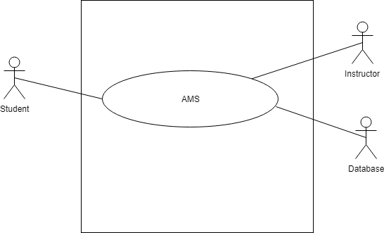

Figure-1: level 0 use case diagram- AMS

Name: Assignment Management System

Primary actor: Instructor, Student, Database

Secondary actor: Result Management System

# Description of level 1 use case diagram-

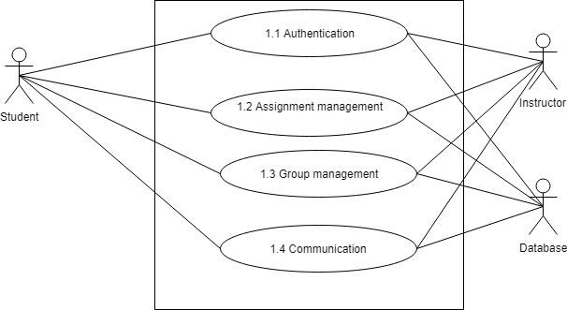

Figure-2: level 1 use case diagram - Subsystem

Name: Subsystem of AMS

Primary actor: Instructor, Student, Database

Secondary actor: N/A

There are 4 subsystems in the Assignment Management System. They are-

* Authentication
* Assignment management
* Group management
* Communication

# level 1.1 use case diagram-

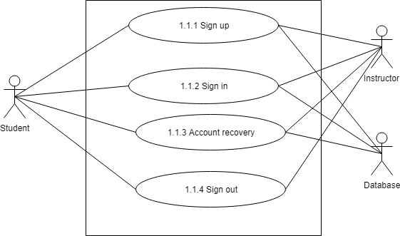

Figure-3: level 1.1 use case diagram – Authentication

Name: Authentication of AMS

Primary actor: Instructor, Student, Database

Secondary actor: N/A

# Description of level 1.1 use case diagram-

Authentication is the process of determining whether someone or something is, in fact, who or what it is declared to be. The authentication subsystem of PMS can be divided into four parts. These are:

* Sign up
* Sign in
* Account recovery
* Sign out

## sign up

* Primary actor: Instructor, Student, Database
* Secondary actor: N/A

### Students action/reply

* Action: Student enter information to sign up.
* Reply: System check validity and store information.

### Instructor action/reply

* Action: Instructor enter information to sign up.
* Reply: System check validity and store information.

Database action/reply

* Store valid data.
* Show data successfully store or not.

## Sign in

* Primary actor: Instructor, Student, Database
* Secondary actor: N/A

### Students action/reply

* Action: Student enter information to sign in.
* Reply: System check validity and store information.

### Instructor action/reply

* Action: Instructor enter information to sign in.
* Reply: System check validity and store information.

Database action/reply

* Store valid data.
* Show data successfully store or not

## Account Recovery

* Primary actor: Instructor, Student, Database
* Secondary actor: N/A

### Students action/reply

* Action: Student enter email.
* Reply: System check validity and store information.

### Instructor action/reply

* Action: Instructor enter information to sign in.
* Reply: System check validity and send pin.

Database action/reply

* Store modified data.
* Show data successfully store or not

# Description of level 1.2 use case diagram-